

10 - Searching & Sorting

Department of Computer Science and Engineering

| Rajalakshmi Engineering College

PA. GE

Department of Computer Science and Engineering

| Rajalakshmi Engineering College

PA. GE
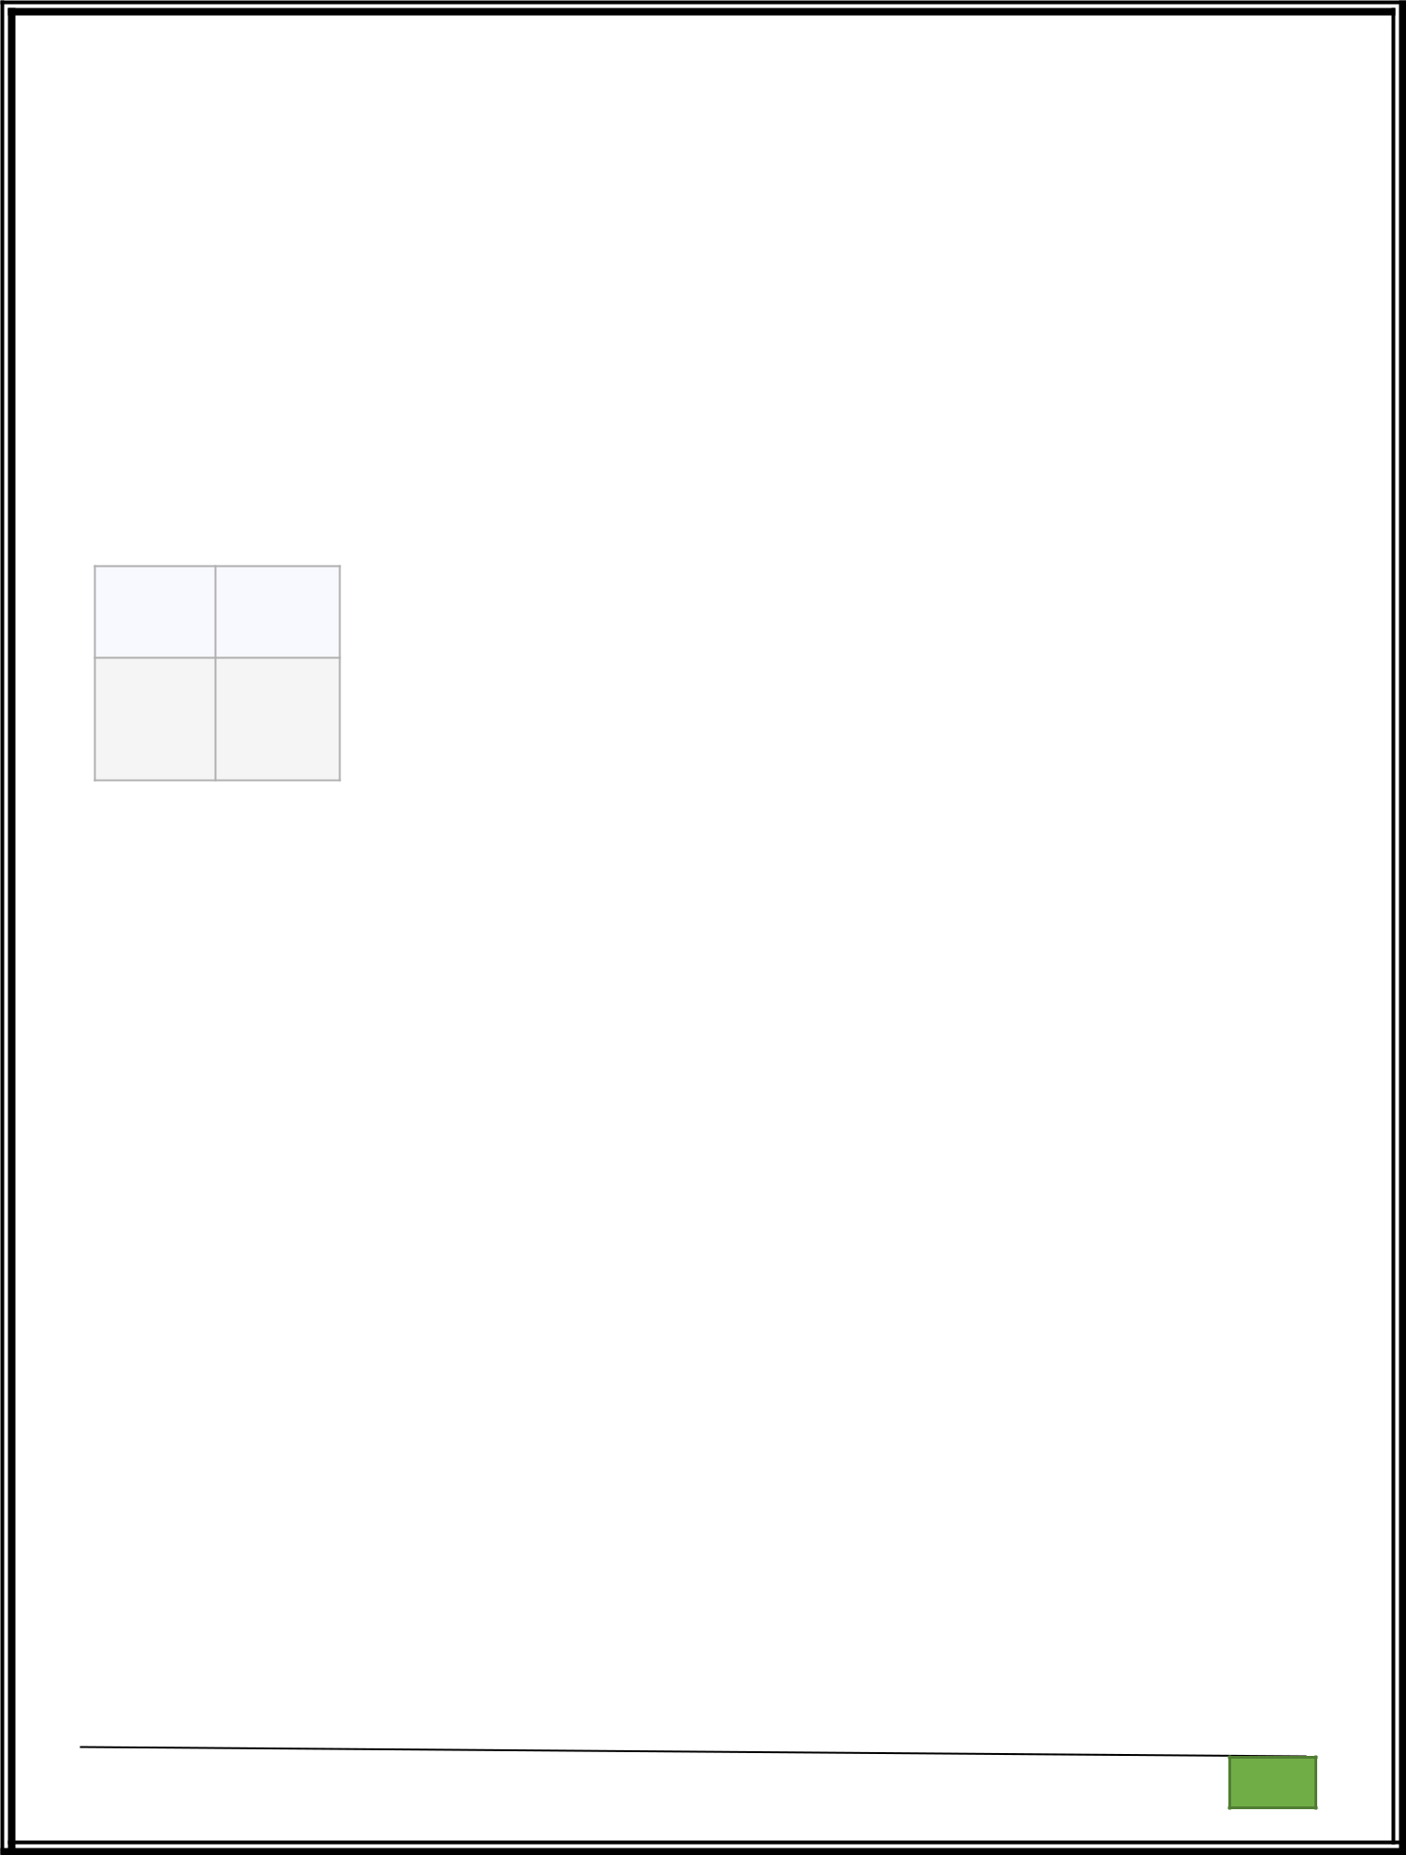
Ex. No. : 10.1 Date: 30.05.2024

Register No.: 231401020 Name: BHUVANESWARI S

Merge Sort

Write a Python program to sort a list of elements using the merge sort algorithm.

For example:

Input Result

- 34568

65438

a=int(input())

l=[]

l.extend(input().split())

for i in range(a-1):

for j in range(a-1):

if(int(l[j])>int(l[j+1])):

t=int(l[j])

l[j]=int(l[j+1])

l[j+1]=t

for i in range(a):

print(int(l[i]),end=" ")

Department of Computer Science and Engineering | Rajalakshmi Engineering College

PA.

GE

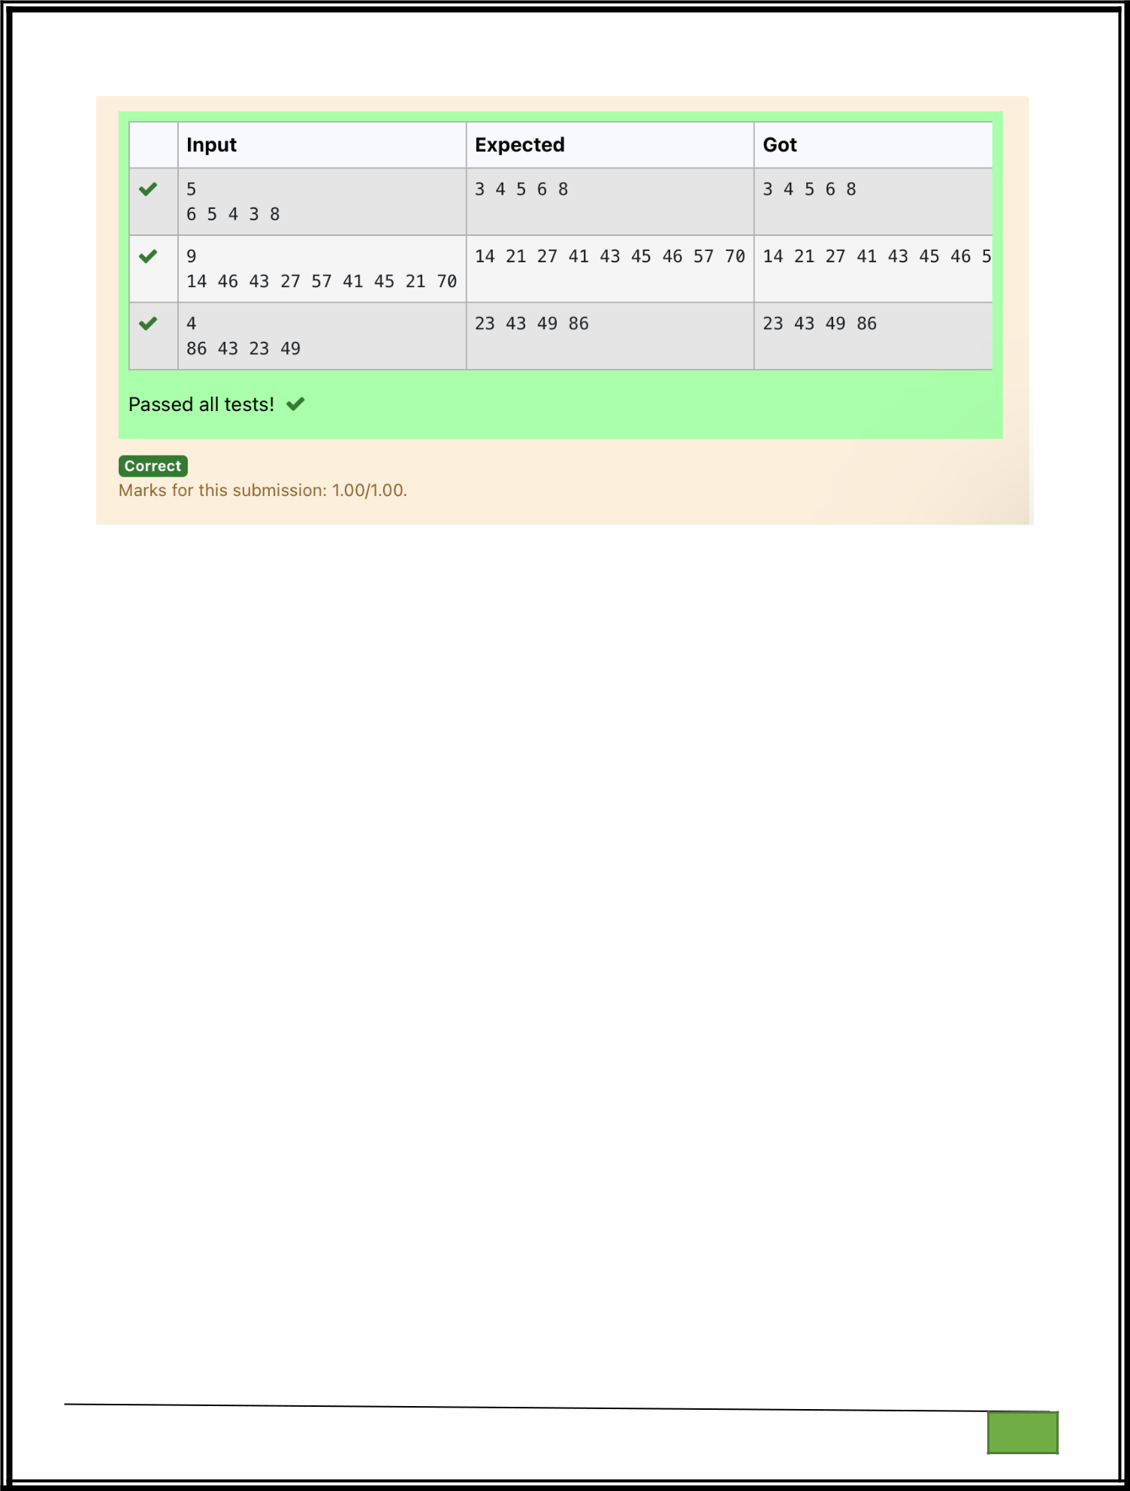

Department of Computer Science and Engineering

| Rajalakshmi Engineering College

PA. GE

Department of Computer Science and Engineering

| Rajalakshmi Engineering College

PA. GE
Ex. No. : 10.2 Date: 30.05.2024

Register No.: 231401020 Name: BHUVANESWARI S

Bubble Sort

Given an listof integers, sort the |  |  |  |  |  | array in ascending order using |  |  |  |  |  |  | the Bubble
Sort algorithm above. Once sorted, print the following three lines:
1. | List is sorted in numSwaps swaps., where numSwaps is the number of swaps that
took | place. |  |  |  |  | first element in the sorted list.
2. | First Element: firstElement, the
3.
3. | Last Element: lastElement, the last element in the sorted list.
 |  |  |  |  |  |  |  |  |  | It took |  |  | 3 swaps to
For example, given a worst-case but small array to sort: a=[6,4,1]. |  |  |  |  |  |  |  |  |  |  |  |  | 3 swaps to
sort the array. Output would be
Array is sorted in 3 swaps.
First Element: 1
Last Element: 6
Input Format
The | first |  | line | contains | an | integer,n , | the | size |  |  |  | of | the list a .
The second line contains n, space -separated integers a[i].

Constraints

- 2<=n<=600

- 1<=a[i]<=2x106.

Output Format

You must print the following three lines of output:

- List is sorted in numSwaps swaps., where numSwaps is the number of swaps that took place.

- First Element: firstElement, the first element in the sorted list.

- Last Element: lastElement, the last element in the sorted list.

Sample Input 0

3

1 2 3

Sample Output 0

List is sorted in 0 swaps.

First Element: 1

Department of Computer Science and Engineering | Rajalakshmi Engineering College

PA.

GE

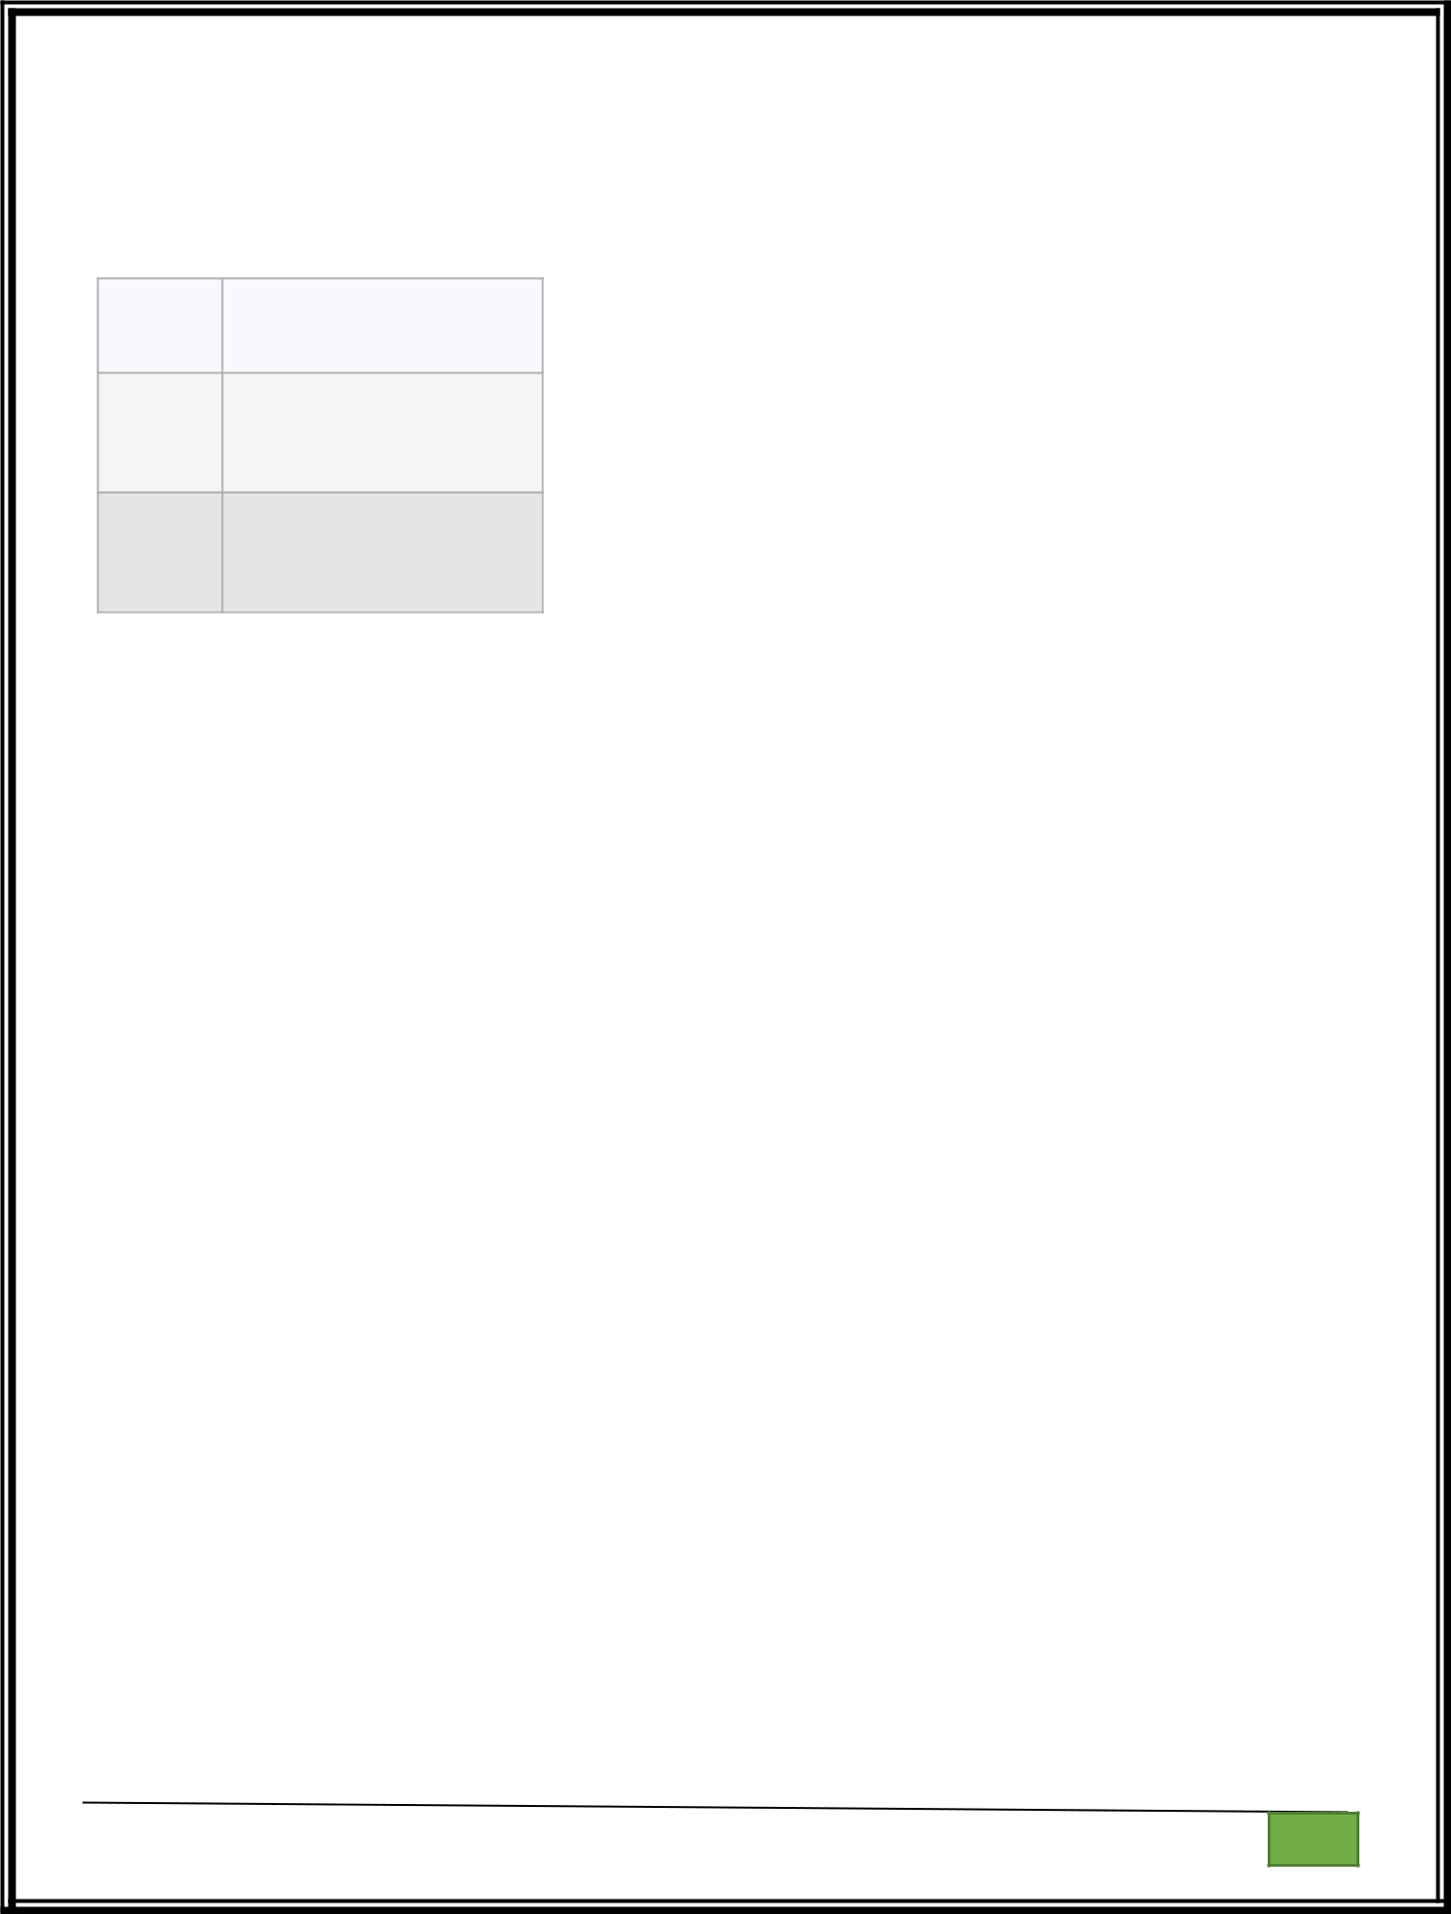
Last Element: 3

For example:

Input Result

- List is sorted in 3 swaps.
- 2 1First Element: 1

Last Element: 3

- List is sorted in 4 swaps.
1 9 2 8 4 First Element: 1 Last Element: 9

def bubble_sort(arr):

n = len(arr)

swaps = 0

for i in range(n):

for j in range(0, n-i-1):

if arr[j] > arr[j + 1]:

# Swap elements

arr[j], arr[j + 1] = arr[j + 1], arr[j]

swaps += 1

return swaps

- Input the size of the list n = int(input())

- Input the list of integers

arr = list(map(int, input().split()))

- Perform bubble sort and count the number of swaps num_swaps = bubble_sort(arr)

Department of Computer Science and Engineering | Rajalakshmi Engineering College

PA.

GE

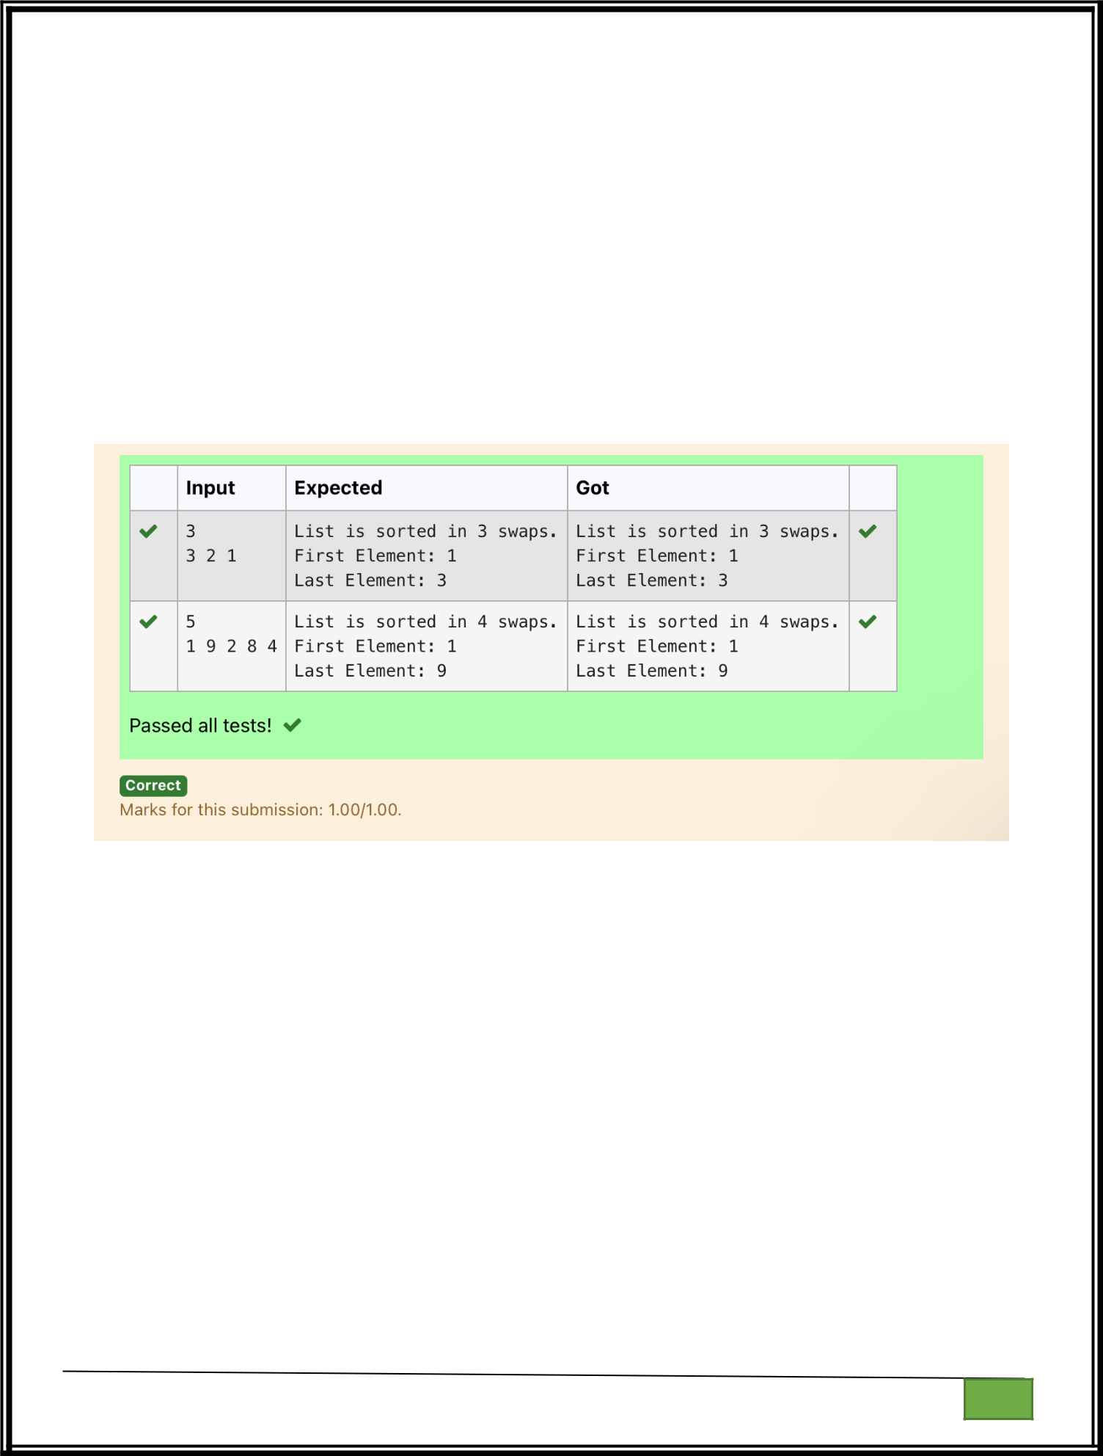
# Print the number of swaps

print("List is sorted in", num_swaps, "swaps.")

- Print the first element print("First Element:", arr[0])

- Print the last element print("Last Element:", arr[-1])

Department of Computer Science and Engineering | Rajalakshmi Engineering College

PA.

GE

Department of Computer Science and Engineering

| Rajalakshmi Engineering College

PA. GE
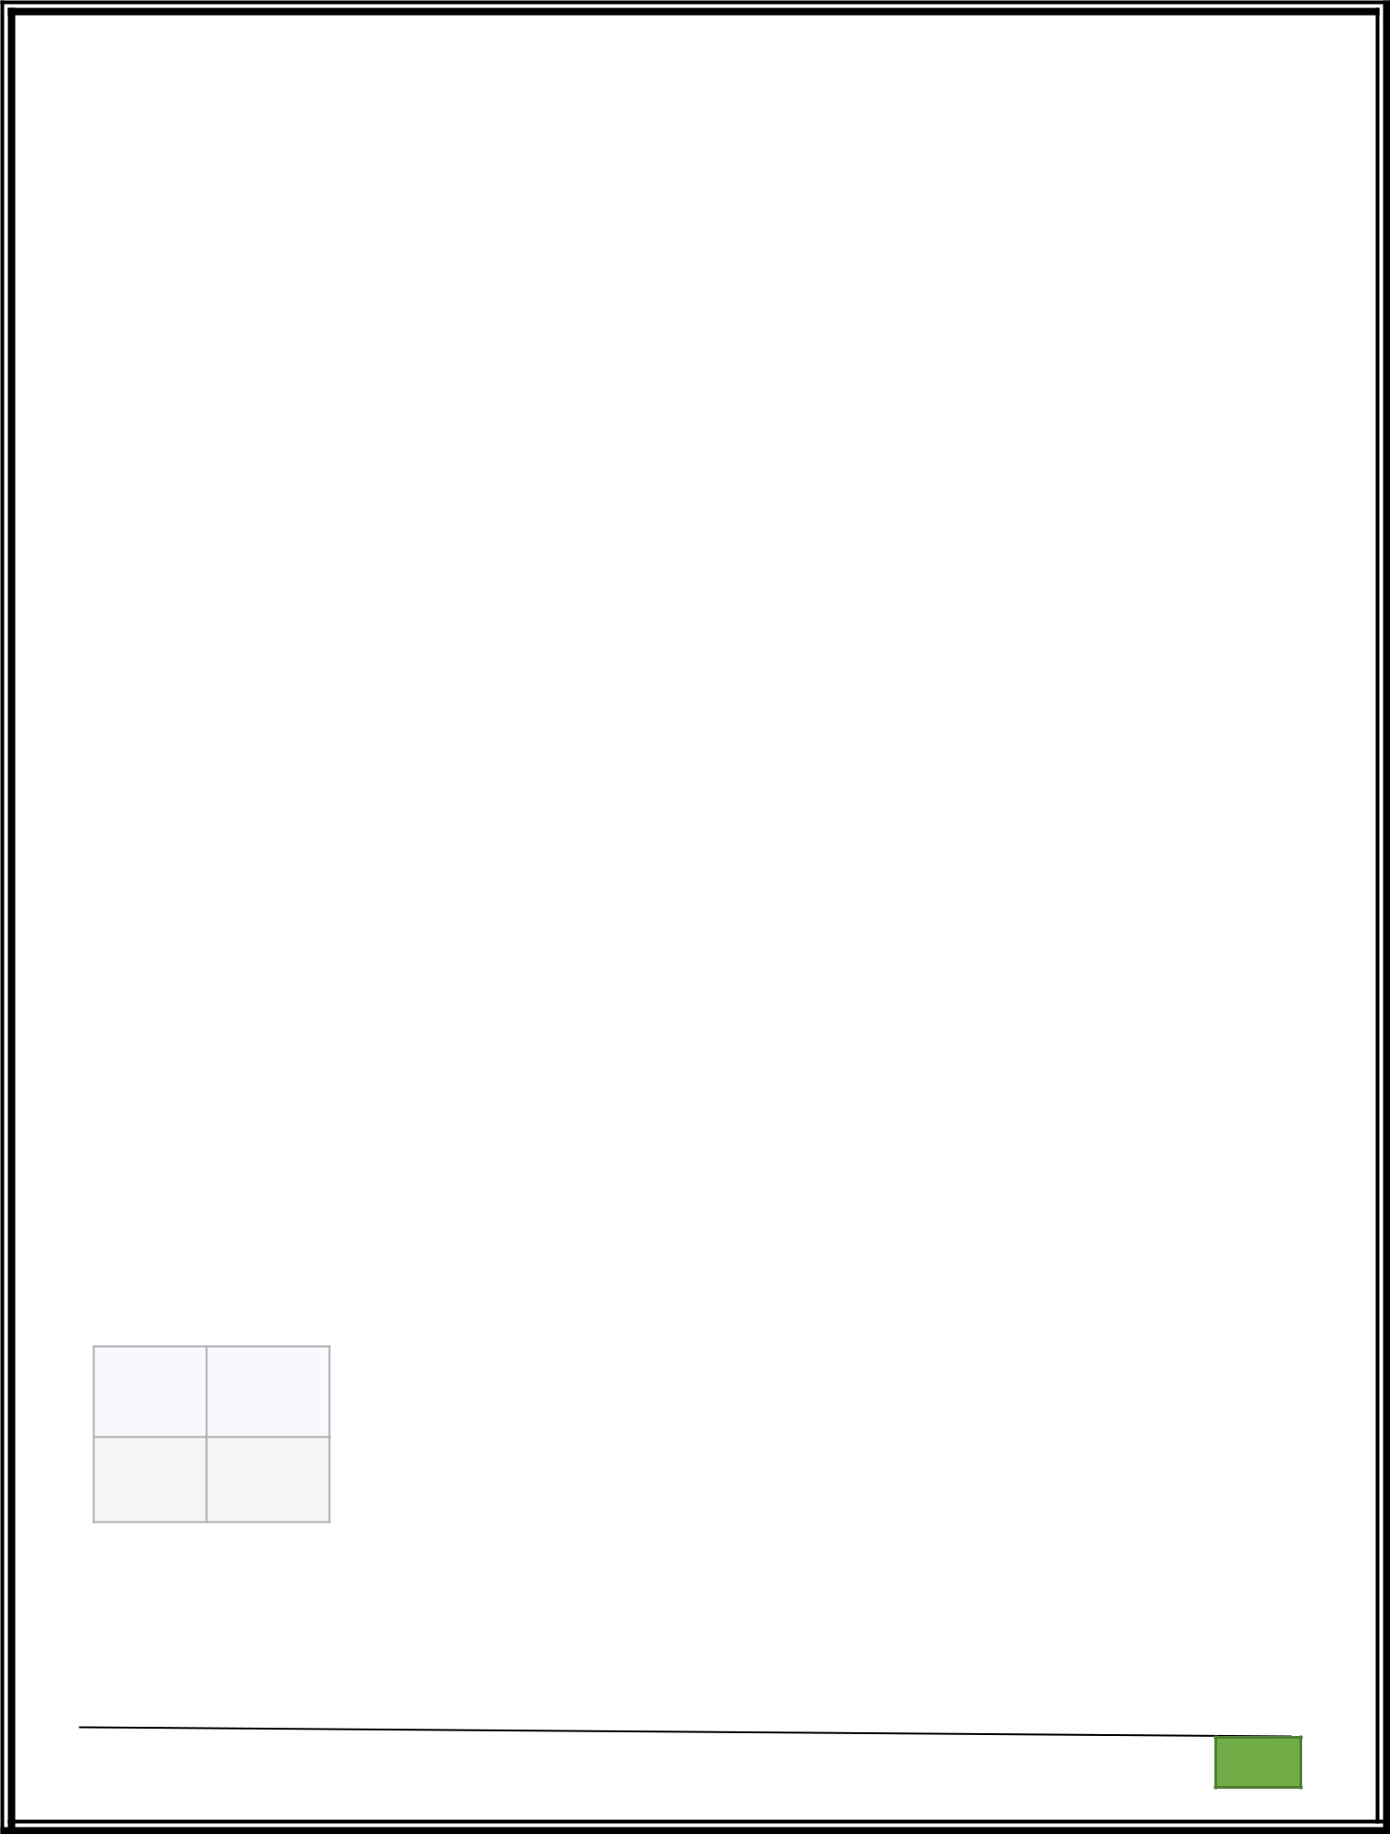
Ex. No. : 10.3 Date: 30.05.2024

Register No.: 231401020 Name: BHUVANESWARI S

Peak Element

Given an list, find peak element in it. A peak element is an element that is greater than its neighbors.

An element a[i] is a peak element if

A[i-1] <= A[i] >=a[i+1] for middle elements. [0<i<n-1]

A[i-1] <= A[i] for last element [i=n-1]

A[i]>=A[i+1] for first element [i=0]

Input Format

The first line contains a single integer n , the length of A .
The second line contains n space-separated integers,A[i].

Output Format

Print peak numbers separated by space.

Sample Input

5

891026

Sample Output

10 6

For example:

Input Result

- 12 8

12368

def find_peak(arr):

peak_elements = []

Department of Computer Science and Engineering | Rajalakshmi Engineering College

PA.

GE

- Check for the first element if arr[0] >= arr[1]:

peak_elements.append(arr[0])

- Check for middle elements

for i in range(1, len(arr) - 1):

if arr[i - 1] <= arr[i] >= arr[i + 1]:

peak_elements.append(arr[i])

- Check for the last element if arr[-1] >= arr[-2]:

peak_elements.append(arr[-1])

return peak_elements

- Input the length of the list n = int(input())

- Input the list of integers

arr = list(map(int, input().split()))

- Find peak elements and print the result peak_elements = find_peak(arr) print(*peak_elements)

Department of Computer Science and Engineering | Rajalakshmi Engineering College

PA.

GE

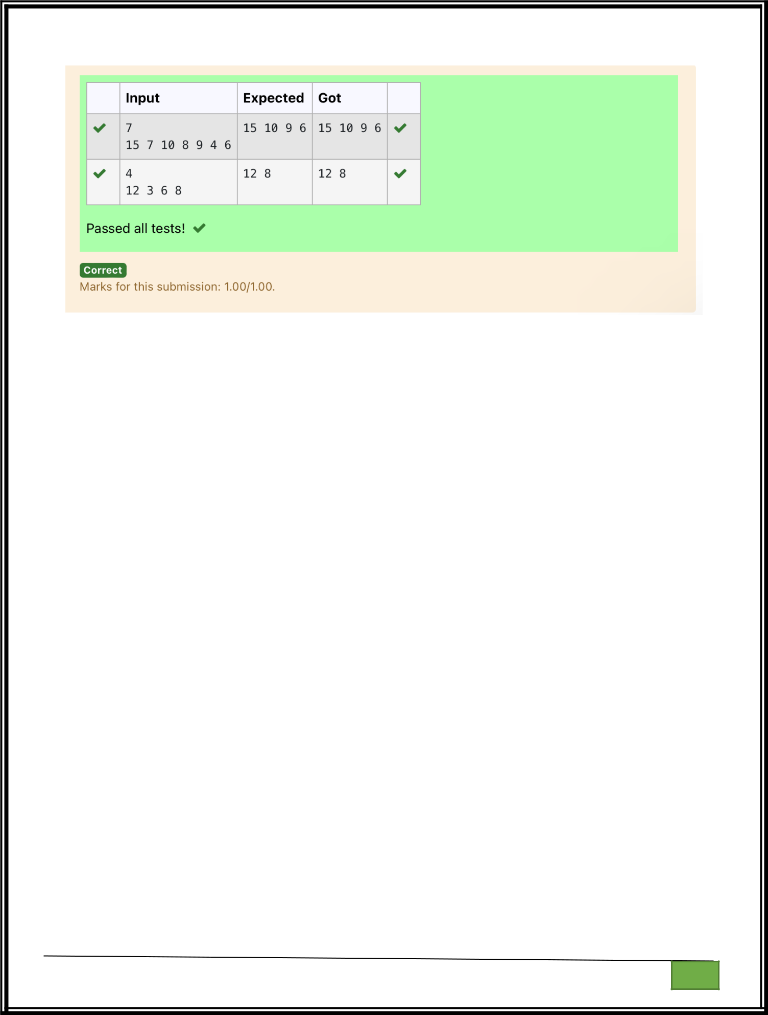

Department of Computer Science and Engineering

| Rajalakshmi Engineering College

PA. GE

Department of Computer Science and Engineering

| Rajalakshmi Engineering College

PA. GE
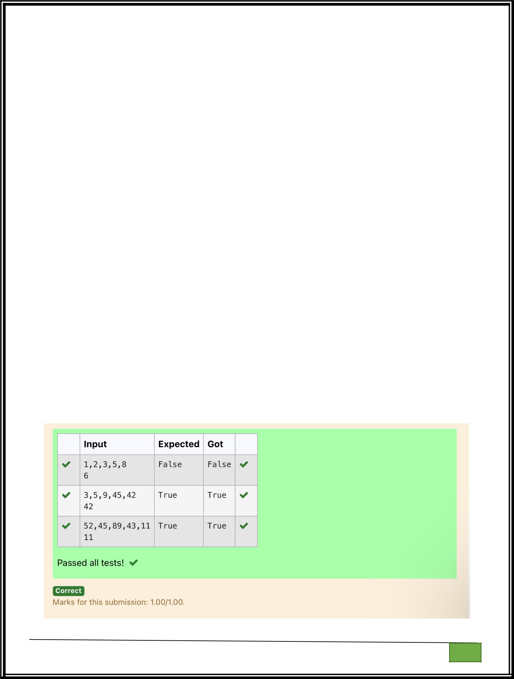
Ex. No. : 10.4 Date: 30.05.2024

Register No.: 231401020 Name: BHUVANESWARI S

Binary Search

Write a Python program for binary search.

For example:

Input | Result
12358 | False
6
35945 | True
42
42

a = input().split(",")

b = input()

print(b in a)

Department of Computer Science and Engineering | Rajalakshmi Engineering College

PA.

GE

Department of Computer Science and Engineering

| Rajalakshmi Engineering College

PA. GE

Department of Computer Science and Engineering

| Rajalakshmi Engineering College

PA. GE
Ex. No. : 10.5 Date: 30.05.2024

Register No.: 231401020 Name: BHUVANESWARI S

Frequency of Elements

To find the frequency of numbers in a list and display in sorted order.

Constraints:

1<=n, arr[i]<=100

Input:

1687949068145

output:

- 2

4 2

5 1

68 2

79 1

90 1

For example:

Input | Result
435345 | 3 2
 | 4 2
 | 5 2

def count_frequency(arr):

frequency = {}

- Count the frequency of each number in the list for num in arr:

frequency[num] = frequency.get(num, 0) + 1

Department of Computer Science and Engineering | Rajalakshmi Engineering College

PA.

GE

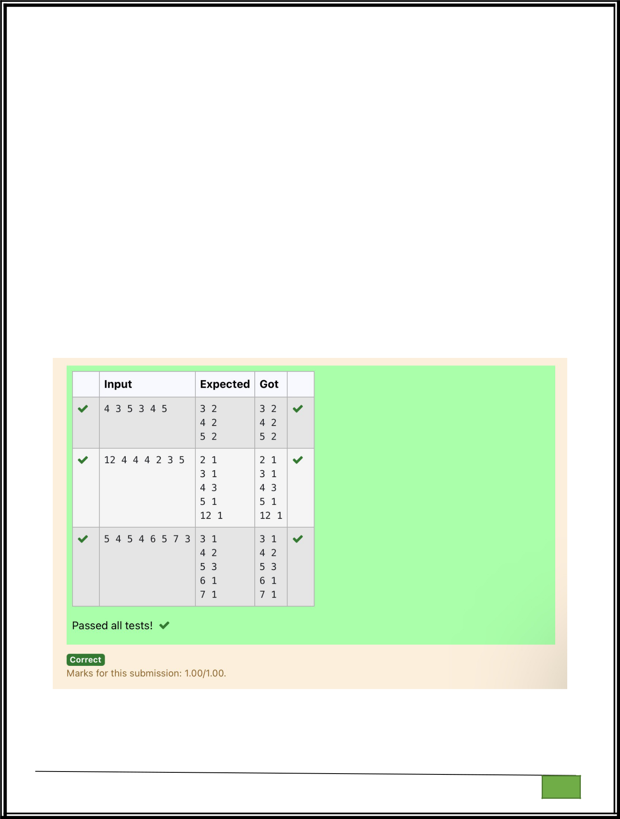
# Sort the dictionary based on keys

sorted_frequency = sorted(frequency.items())

  - Print the frequency of each number for num, freq in sorted_frequency:
print(num, freq)

- Input the list of numbers

arr = list(map(int, input().split()))

- Count the frequency and print the result count_frequency(arr)

Department of Computer Science and Engineering | Rajalakshmi Engineering College

PA.

GE

